|  |  |  |  |  |
| --- | --- | --- | --- | --- |
| The Importance of sextons   The thousands of tombstones and other grave markers bely the many more burials that took place in the cemetery and we would have no record of them without the people who helped to allow us to remember.  While we can decern the information on some, others have worn away due to natural processes. |  | The History of Nashville Rest Here |  |  |
| A cemetery with many headstones |  | Location: 1001 4th Ave S, Nashville, TN  P.O. Box 150733, Nashville, TN 37215-0733 |  |  |

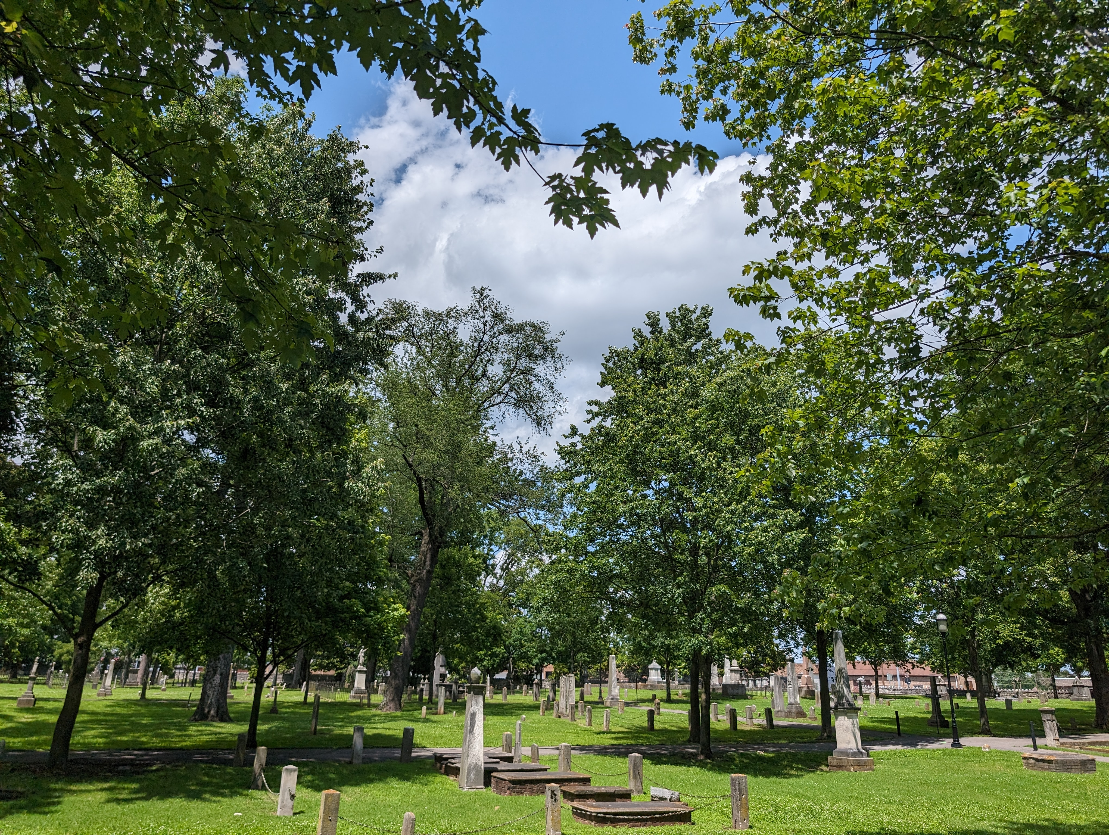

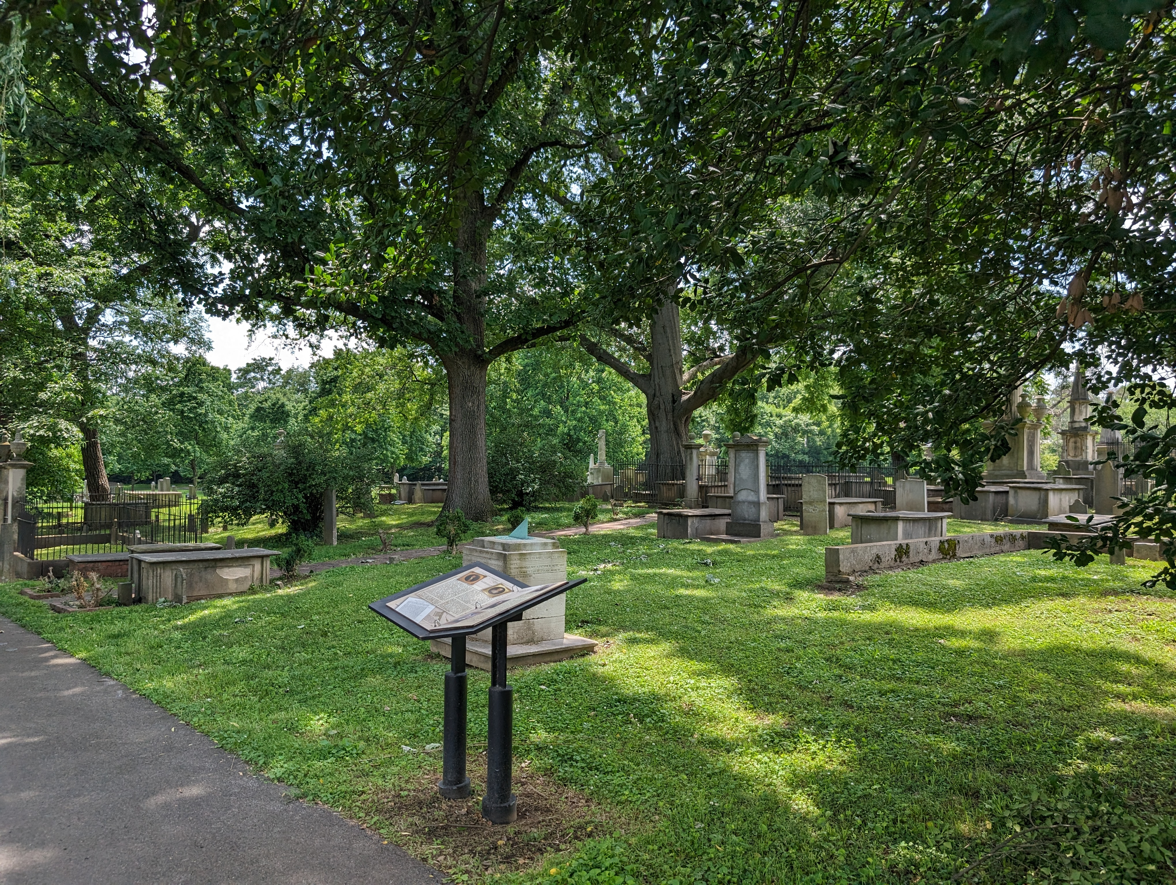

|  |  |  |  |  |
| --- | --- | --- | --- | --- |
| sextons The job of the Sexton at the City Cemetery was difficult. He oversaw arrangements for all burials, in having the graves dug prior to funerals and filled after interments, in keeping the Interment Books and in collecting the fees for burials. During periods of Epidemics this was unending work. We must be grateful for the endeavors of the Sextons in faithfully keeping the Interment Books at the City Cemetery so that we have knowledge of the many people who were buried in this cemetery. Today of the 19,745 burials in the Interment Books, only a fraction has tombstones. Of the 3,000 tombstones in the cemetery, in 2006, only two thousand tombstones had legible inscriptions. |  | City Cemetary Rules and conditions  The Cemetery is a Gragile Historic Site. Please Treat it with Respect and Observe the below. |  | Contact us  (615) 862-7970  *Please call the phone number on the front entrance sign if the gate is locked between* *9:00 a.m. and 5:00 p.m.* |